Effects of psilocybin on psychological distress levels among Canadian adults who had not previously used: a cohort study

J. Andres Delgado-Ron¹, Gina Martin², Laura Baracaldo¹, Sandra Allison³, Daniel J. Kruger⁴, Zach Walsh⁵, Shannon Dames⁶, Cecilia Benoit⁷, Kiffer G. Card¹
- Faculty of Health Sciences, Simon Fraser University, Burnaby, Canada

Abstract
A growing body of evidence suggests that psilocybin improves mental health outcomes. Clinical trials have shown sustained benefits comparable to standard care but with limited generalisability, while observational studies capture broader populations but with shorter follow-up periods (typically months). This study addressed both issues by examining changes in psychological distress in an online cohort of Canadian adults assessed across three timepoints who had never used psilocybin at baseline (n = 110). During the first year, 28 participants reported using psilocybin, while 82 did not. Of the non-users, 40 continued to abstain during follow-up, 1 initiated use in the second year, and 41 were lost to follow-up (50.0%). Among the 28 users, 11 reported repeated use at follow-up, while 17 were lost to follow-up (60.7%). A lagged dependent variable model showed that psilocybin use was associated with a 2.63-point reduction in Kessler-6 distress scores (95% CI: −4.70 to −0.56), adjusting for baseline levels and confounders. Within-person analyses showed an average 3.82-point reduction (95% CI: −5.80 to −1.84). Pairwise comparisons indicated that reductions were sustained one year later among a subset of users (n = 14), whereas no significant changes were observed in controls who provided second-year follow-up data (n = 40). These findings suggest that psilocybin use is associated with sustained reductions in psychological distress in a naturalistic adult cohort. These results also highlight a regulatory gap, suggesting a need to re-evaluate access frameworks to safely expand availability for individuals experiencing psychological distress.

Keywords: Psilocybin, Psychological Distress,

Introduction
The analysis of historic data on the prevalence of major depression disorder and general anxiety reveal an upward trend in diagnosis worldwide (1,2). The most recent available global estimates (2021) show that these mood disorders account for approximately 11% of all global years lost due to disability (1). Post-pandemic reports suggest this trend worsened through COVID-19 and will likely have long-lasting impacts due to the interplay between pandemic-related complications (such as long covid) and depression (3–5). Taken together, these findings underscore the urgent need for scalable, evidence-based interventions to address the rising burden of our global mental health crisis.
A recent report by the World Health Organization (6) identified childhood sexual abuse, bullying by peers, and intimate partner violence as relevant modifiable risk factors for major depressive disorder and anxiety (accounting for over 20% of all disability-adjusted life year lost to these conditions). Framing these events as risk factors is useful to establish preventive policies. However, the nature of said risk factors also illustrates the complexity of mood disorders as dynamic patterns of disrupted physical and emotional development, social functioning, and physiological regulation that unfold over the life course (7). Such complex processes contrast with the most common approach to treat mood disorders: emphasizing chemical imbalance and prioritizing symptom relief.
A psychedelic experience entails a profound and rapid re‑configuration of one’s perceptual, emotional, and self‑referential frameworks, characterised by and altered sense of both existence and the self (8). A qualitative study of patients receiving psilocybin for treatment-resistant depression identified two core psychological shifts: (1) moving from a state of disconnection or disengagement—from themselves, others, and the wider world—toward increased connectedness, and (2) from habitual avoidance of difficult emotions toward acceptance (9).
Although some hypothesis have tried linking such changes to neuromodulatory effects, including serotonin receptor activity and changes in the default mode network (10,11), such correlations, while relevant, remain secondary to the psychedelic experience itself. Indeed, participants who report greater levels of mystical‑type experience show stronger responses after the first dose (but not necessarily after second or third doses), which supports the view of a phenomenological, rather than purely pharmacological, mechanism (12).
Psychedelic treatment has shown overall positive results for treating diverse mental health conditions, including PTSD, depression, anxiety, and substance use disorders. However, access to psilocybin is still heavily regulated. In Canada, it is considered illegal to possess, traffic, or produce without authorization. Its use in unregulated settings is illegal, and it has only been approved for specific conditions based on existing evidence: end-of-life distress and treatment-resistant major depressive disorder. A total of 200 patients were granted access to either psilocybin or MDMA during the first two years of Canada’s Special Access Program (13). Similar restrictions are often imposed on the eligibility conditions of clinical trials outside Canada (14), which limits the overall generalizability of their positive findings, both in short- and long-term (15–17). For example, the youngest age of any participant was 34 years, and there is a general lack of representation of visible minorities relative to the general population (18). Even outside trials, no studies have included adolescents up to April 2025 (19).
Despite the limited generalizability of randomized trials, there is a growing body of evidence studying the unregulated or “naturalistic” use of psilocybin. Access to, and consumption of, psychedelics has been de facto legalized in several jurisdictions, meaning people can readily access the compounds through online or in‑person stores at reasonable prices. Criminal prosecution due to consumption is relatively rare, too. This has prompted researchers to establish guidelines for community-based consumption for both medical professionals and the general public (20).
Examining real‐world consumption of psychedelics allows for a broader view of how these compounds perform in less controlled, more representative settings. For instance, a longitudinal cohort study (21) of psilocybin in naturalistic settings reported improvements in mental health outcomes over a three‑month period, aligning with the findings from controlled trials. However, naturalistic studies that are representative of the broader population lacks information about long-term, with the typical follow-up periods being weeks or a few months (22).
Our research seeks to contribute to this growing body of evidence by examining the benefits and long-term effects of psylocibin use in an online sample of Canadians which reported psylocibin use from 2023 to 2025. Our primary objective on this study was to quantify the effect of psilocybin use on the psychological distress levels of Canadian adults. We hypothesized that psilocybin use would lower psychological distress based on previous evidence of psychedelic use on other mental health outcomes. Our secondary objective was to determine whether said changes were sustained over time. We hypothesized they would because of their long-lasting impact on the sense of self and reality.

Methods

Study design
We employed a closed cohort design nested within the larger Tips and Recommendations for the Ingestion of Psilocybin study (23). Participants were selected if they have not consumed psylocibin during their lifetime at the start of the study period (2023). The study size was determined by the number of participants who provided data for the first follow-up period (2024), some of which also provided data in 2025 (wave 3). Exposure and outcome data were collected during all three waves. This study was approved by the Research Ethics Board of Simon Fraser University (#30001311).

Setting
Participants were recruited through Meta via paid advertisements and through organic posts on Twitter, Reddit, and LinkedIn. Email distribution campaigns were also used. All available venues offered a 1:100 chance of winning a $100 cash prize (23). Participants who showed interest were directed to a website with information about the study, including eligibility criteria (residing in Canada and being 16 or older), which later linked to a consent form. Upon consenting to being considered for participation, they were directed to Qualtrics, a secure online platform specialized in online surveys. Bot detection and enhanced control for ballot box stuffing were enabled to prevent to prevent fraud.

Survey and data integrity
The baseline survey was developed in consultation with academic advisors and contained around 250 items asking about opinion, use, and experience of psychedelics. It also assessed mental health constructs through validated instruments. Branching logic helped reduce the burden of response, particularly for users, who had a longer questionnaire. The survey was tested among a group of students and researchers and iteratively adjusted before launch for Wave 1 (Feb 4 to Apr 4, 2023). The follow-up surveys for Waves 2 (Feb 2 to Mar 23, 2024) and 3 (May 27 to July 4, 2025) were shorter, with approximately 200 and 100 items, respectively. Participants who provided logically inconsistent responses (e.g., reporting no previous use at baseline and use in the past five years after one-year follow-up) or who lacked outcome data were excluded.

Variables
The Kessler Psychological Distress Scale (K6) was our main outcome. This six-item scale was designed to measure serious mental illness and has been thoroughly tested for validity and reliability in the general population across multiple countries (24,25). Subjects are asked about feeling: (1) nervous, (2) hopeless, (3) restless or fidgety, (4) so depressed that nothing could cheer you up, (5) that everything was an effort, and (6) worthless, during the past 30 days. The available responses (“None of the time,” “A little of the time,” “Some of the time,” “Most of the time,” and “All of the time”) are each scored from 0 to 4 and then summed, yielding a possible total score range of 0 to 24.
Participants were asked to indicate the recency of their psilocybin use, with response options ranging from “in the past week” to “more than 5 years ago” or “never used psilocybin.” A secondary variable was created to assert whether the participants had consumed psilocybin within the last year based on their responses, and this was our main exposure for Waves 2 and 3.
Other variables included in our study were age (collected as continuous), gender (men, women, non-binary), education (grouped as “less than bachelor” and “bachelor or higher”), past use of “prescription medication for emotional, psychological, or mental health concerns” (yes, no). Data on the number of doses (range 0 to 50 or more) by approximate weight/size (micro, light, medium, strong, hero) were collected from some participants but not included in the main analysis.

Other variables
Observational data are susceptible to confounding and other biases that can distort causal inference. To clarify these relationships and inform analytic decisions, we developed a directed acyclic graph (DAG) to represent the relationships between sociodemographic characteristics, mental health treatment, psilocybin use, and psychological distress over time, including some unobserved variables (Figure 1).
Gender, age, income, and education are upstream determinants: they influence health-seeking behavior, as evidence suggests that men, younger individuals, and those with lower education are less likely to seek professional mental health care (26,27). These sociodemographic factors also affect baseline psychological distress (28). They also shape psilocybin use through both risk aversion (e.g., women and older adults are generally more cautious) and differences in access linked to socioeconomic status (29). Health-seeking behavior was assumed as a parent of ever having been prescribed medication for emotional, psychological, or mental health concerns, since prescriptions require prior professional contact. Past prescription use, in turn, was assumed to lead to psilocybin use, reflecting the Canadian Special Access Program’s requirement for a diagnosis of treatment-resistant depressive disorder and evidence of prior treatment (13). Finally, both baseline psychological distress and psilocybin use are assumed to influence psychological distress at follow-up, consistent with previous research on other mental health outcomes (14,23,30–32).
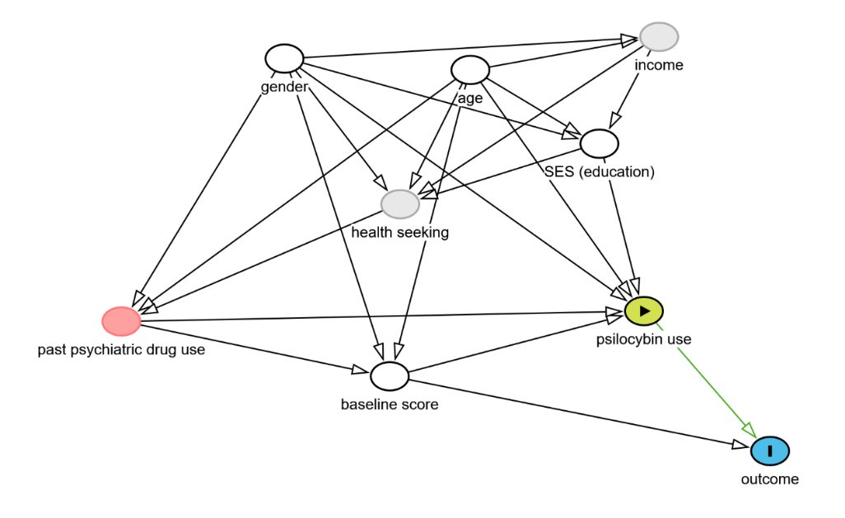
Figure 1. Directed Acyclic Graph showing the assumed relationship between variables in the cohort study.
The temporal relationship between variables also risks confounding. For example, a few respondents selected their last consumption was “in the past week” while the outcome asks about the past 30 days. However, we worked under the assumption that the exposure preceded the outcome because an early exposure may have occurred for these participants because they reported multiple doses during the last year in all cases. Finally, it is also possible for some participants to first have tried psilocybin before other prescribed psychiatric drug (as this question was asked concurrently). However, we worked under the assumption that past psychiatric use led to psilocybin use based on the structure of the special access program and the broader language used to ask about prescription medication (“ever used”).

Statistical methods
All statistical analyses were performed using R version 4.5.1 (33). Data about psilocybin use was described using counts and proportions. Differences between exposed and unexposed groups were inspected using chi-square and t-tests. Given only one participant tried psilocybin during Wave 3 for the first time, we chose to use data from Waves 1 and 2 to estimate the effect of psilocybin use on psychological distress.
Several analytical approaches were tested to ensure robustness and account for both observed and unobserved confounding. First, we fitted a lagged dependent variable (LDV) model in a wide format dataset, adjusting for the K6 score at baseline and time-invariant covariates (i.e., age, gender, and education). These set of covariates provided sufficient adjustment to prevent bias based on observables covariates (34). LDV is useful when allocation is based on real-world effect rather than randomization and the method of choice above alternatives like change in scores when the outcome at baseline is a competing exposure (35,36).
Second, we used an inverse probability of treatment weighting approach, predicting the exposure based on the same set of covariates, essentially creating a pseudo-population in which the exposure is independent of them. Extreme weights (>99th percentile) were trimmed to prevent instability (37). Finally, we fit a fixed-effects models in long-form data, therefore adjusting for all time-invariant unobserved confounders through within-person estimates.
For our secondary objective, we analyzed the distribution of K6 psychological distress scores over time by intervention status using the Friedman non-parametric test, followed by a Durbin–Conover test for group-wise comparison (38). Compared periods, therefore, accounted for repeated measurements within participants. The non-parametric alternative was chosen given the small number of participants who had been treated and reported data for all three waves.

Results

Participants
Among 1,249 participants in the Tips and Recommendations for the Ingestion of Psilocybin study, 540 consented to follow-up and provided valid responses for Wave 2, therefore constituting the original cohort for the broader study. We sampled a subset of 110 respondents who, based on their responses through all waves of the survey, had never used psilocybin, after excluding four participants with inconsistent responses (e.g., selecting “never” use at baseline and “in the past five years” at follow-up) and one participant lacked outcome data. Among our final analytic sample respondents for Waves 1 and 2 (n=110), 47.3% (n=52) provided information for Wave 3 whereas the remaining 52.7% (n=58) were lost to follow-up.

Descriptive data
Among the analytic sample of 110 participants, 82 participants did not try psilocybin in the first year, 40 continued not to use it during follow-up, 1 tried it in the second year, and 41 were lost to follow-up (50.0%). No significant differences across age, K6 scores, or strata of education, gender, and past use of prescription drugs were found between groups that finished the study and those lose to follow-up.
Among the 28 participants who reported trying psilocybin at any dose during the first year, 11 tried it again in subsequent follow-up, while 17 were lost to follow-up (60.7%). Participants from the treatment group who were lost to follow-up had lower K6 mean scores at baseline (14.18 vs. 9.29; p= 0.015) and Wave 2 (9.45 vs. 6.06; p= 0.136) and were more likely to identify as women (82.4% vs 27.3%; p-adj= 0.048) than men compared to those who finished the study.
Participants in the intervention and control groups did not significantly differ from each other. All participants characteristics are presented in Table 1.
Table 1. Sociodemographic characteristics and outcome data across waves 1 and 2 for cohort participants.
Variable | Control  (n=82) | Intervention  (n=28) | p value
Age (mean (SD)) | 36.26 (16.03) | 29.86 (14.71) | 0.065
Education = Less than bachelor (%) | 14 (17.1) | 6 (21.4) | 0.816
Past use of prescription drugs (%) | 49 (59.8) | 15 (60.0) | 1
Gender (%) |  |  | 0.92
Man | 18 (22.0) | 6 (21.4)
Other | 12 (14.6) | 5 (17.9)
Woman | 52 (63.4) | 17 (60.7)
K6 score at baseline (mean (SD)) | 10.21 (6.69) | 11.21 (5.33) | 0.472
K6 score at follow-up (mean (SD)) | 9.38 (6.15) | 7.39 (5.84) | 0.138
SD=Standard deviation; p values derive from chi-square test for categorical variables and t-tests for numeric variables.

The number of doses for year one ranged from 1 to 30, with a median of 4 doses and a mean of 6.2 doses. The distribution was positively skewed (4.8), indicating that a few participants used psilocybin much more frequently than most. These patterns persisted during Wave 3, with a median of 4 doses, a mean of 6.7 doses, and a positively skewed (2.6) distribution.

Main effect
According to the LDV model, the follow-up K6 score increased by 0.61 points (95% CI: 0.47 to 0.75) among participants who participated in Waves 1 and 2 by each unit of increase in the baseline K6 score, before adjusting for sociodemographic variables. The use of psilocybin reduced the K6 score by -2.60 (95% CI: -4.63 to -0.57; R² = 0.427; R² adjusted = 0.416) in the same model. The LDV estimate did not significantly change after adjusting for sociodemographic variables (Table 2). Inspection of residuals versus fitted values indicated no obvious deviations from homoscedasticity or nonlinearity, suggesting that model assumptions were reasonably met (Supplementary Figure S1).
Only two participants had extreme weights before trimming. The IPTW produced balanced groups in terms of age, gender, education, and baseline K6 score (SMD=0.03 in all cases). Propensity score distributions for the treatment and control groups showed adequate overlap, indicating sufficient common support for estimating treatment effects (Supplementary Figure S2). The IPTW model estimated a score reduction of -2.58 (95% CI: -5.07 to -0.08; R² = 0.05; R² adjusted = 0.04) before adjusting for sociodemographic variables and baseline score. Once more, the model did not significantly change after adjustment for sociodemographic variables (Table 2).
Finally, the within-subject score change attributable to treatment between waves was estimated at -3.82 (95% CI: -5.80 to -1.84) by the fixed-effects model (within R² = 0.12).
Table 2. Coefficients for the Lagged Dependent Variable (LDV) and Inverse Probability of Treatment Weighted (IPTW) models.
Variable | LVD model estimates | 95% Conf.  Intervals | IPTW model Estimates | 95% Conf.  Intervals
(Intercept) | 3.69 | 0.16 to 7.23 | 2.77 | -1.73 to 7.27
Treatment | -2.63 | -4.70 to -0.56 | -2.49 | -4.53 to -0.46
Baseline K6 score | 0.60 | 0.45 to 0.76 | 0.57 | 0.39 to 0.76
Age | 0.00 | -0.06 to 0.07 | 0.03 | -0.06 to 0.12
Gender [Other] | 0.73 | -2.35 to 3.80 | 1.51 | -2.05 to 5.07
Gender [Woman] | -1.16 | -3.42 to 1.10 | -1.11 | -4.06 to 1.83
Education [< bachelor] | 0.25 | -2.15 to 2.64 | 1.28 | -1.94 to 4.50
R2 / R2 adjusted |  | 0.441 / 0.409 |  | 0.410 / 0.375

Persistence of effect over time
The all pairs-comparison test did not detect significant differences within-subject across time periods in the control group (n=40). The median value for the score changed from 8 at baseline to 7 in both follow-up years, with a relatively similar distribution. Conversely, the median distress score in the intervention (n=14) group dropped from 13.5 at baseline to 6.0 during the first year of follow-up and 9.0 at the end of the study period. The differences were statistically significant compared to baseline values even after accounting for multiple comparisons. No significant differences were found between the scores from Waves 2 and 3 in the intervention group (Figure 2).
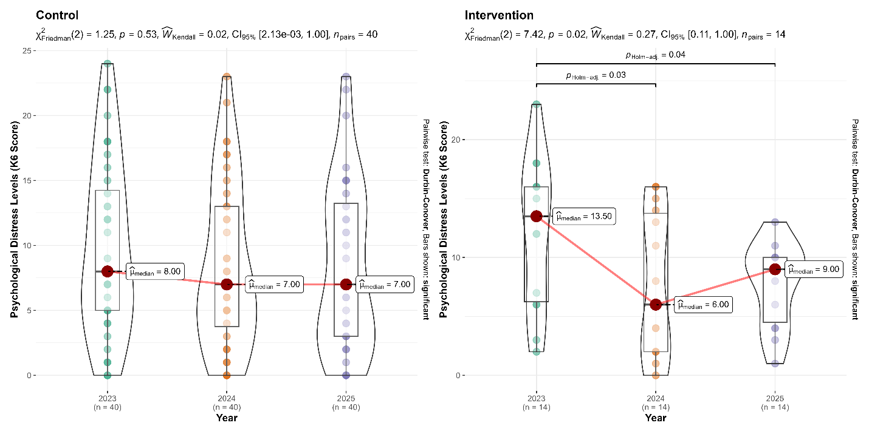
Figure 2. Distribution and pairwise comparisons of psychological distress levels over time, by intervention status.

Discussion

Key results
We hypothesized that psilocybin use would lower the level of psychological distress in a sample of naive users. Our results were confirmed, with a mean score reductions of 2.6 points after adjusting for covariates (n=110). Within-person effects were stronger, with mean score reductions of 3.8 points after treatment. We also hypothesized the effect of psylocibin would be sustained over time, which we confirmed in a small subset of participants (n=14) who provided follow-up data for a second year. The scores for these participants were significantly lower compared to baseline values in years 2 and 3 and did not significantly differ from each other.

Limitations
Our study has several limitations. Online data collection is self-reported and risks introducing recall bias. However, psilocybin use is often cited as one of the most memorable life experiences by past users (39), which makes recall bias for the exposure—and other variables in the model, which are stable through time—unlikely. Our ability to clearly assert the temporal relationship between some variables was also limited by the data collection instrument. People reporting last psychedelic use could select “past week” whereas the outcome assessed the psychological distress in the past month. However, this only occurred with two participants which reported having taken multiple doses, making it more likely that the exposure preceded the outcome. Moreover, given the direction of the effect, such scenario would bias the estimate towards the null, and it is unlikely to affect the overall conclusion. Conversely, past research using self-reported data has found higher benefits than experimental settings (40). We tried to address this by using validated psychological instruments that had been thoroughly tested in several populations.
Observational studies always risk bias by unmeasured confounding. We tried to mitigate this risk by estimating a fixed-effect model that would account for time-invariant individual characteristics and isolate within-person changes. However, residual confounding from time-varying factors not captured in the model may still influence the observed associations, underscoring the need for cautious interpretation.
Regarding the stability of estimates, we found a relatively higher proportion of participants in the intervention group were lost to follow-up compared to the control group (60.7% vs 50%). When examining the factors associated with missing data in wave 3, we found participants lost to follow-up had lower scores for psychological distress in waves 1 and 2 and were more likely to identify as women, but age and education were not related to attrition as previously reported (41). This pattern suggests that attrition was not completely random and could have influenced our results. However, the overall trends observed in the remaining sample were consistent with earlier waves, providing some reassurance about the robustness of the estimates.

Interpretation
Antidepressant drugs are the first line of treatment for both depression and generalized anxiety, recommended with or without psychological therapy (42,43). When used on their own, such population-level intervention discounts the knowledge of the patient about his own condition. This well-known epistemic injustice often leads to reduced professional engagement and undermined trust in public health systems (44–46). Moreover, current first-line antidepressants are under scrutiny due t (1) o a lack of support for the presumption of a chemical imbalance as the cause (rather than a symptom) of mental health outcomes, (2) the questionable research practices in randomized control trials that led to the establishment of antidepressants as first-line therapy, including concealing adverse effects, (3) the limited effect of these drugs compared to active placebos, (4) their poor safety profile (including increased risk of suicide), and (5) the long-term consequences of antidepressant use and withdrawal (47–51).
Our collective failure to improve global mental health raises the question about the adequacy of such impersonal and reductionist approach. This has prompted new conceptual approaches to overcome said limitations. Enactivism, for example, redefines mental health as an embodied interaction between a person and its environment: the mind is both and the pathology could lie in either elements or its interplay (52). Depression, under this framework, could be understood as an inability to connect meaningfully with life, because the world offers fewer opportunities to act, enjoy, or engage. Generalized anxiety could be understood as interaction with a world that feels threatening to the patient (53). The environment-person dysregulation is then addressed in tandem through a joint negotiation about what is pathological and what is not, therefore, overcoming the abovementioned epidemic injustice of ignoring the patient as a knowledgeable agent of his own condition (52).
While an enactivist approach highlights the negotiated, context-sensitive nature of mental health, it is inherently challenging for public health because it resists fixed definitions and standardized protocols, which many medical professionals rely on to guide diagnosis, treatment, and population-level interventions (52). Moreover, even if we acknowledge that environmental factors contribute causally to mental health, public health interventions are inherently limited in their ability to reshape the world, facing constraints in how much they can alter social, economic, and cultural conditions. Over time, patients’ difficulties in making sense of their environment—a core concern in enactivist frameworks of mental health (54)—may become reinforced by the public health system’s own limitations in acknowledging and responding to this dynamic interplay of person and world.
Conventional therapeutic approaches often produce only temporary shifts in mood, without fundamentally addressing the ongoing relationship between the individual and the environment. Psychedelic experiences, by contrast, appear to engage individuals in a way that is deeply personal. Across diverse cultural and demographic contexts, people report core phenomenological features such as ego-dissolution, awe, and profound insight, yet each experience is interpreted and integrated through the individual’s unique life history, values, and social circumstances (55–57). From an enactivist perspective, meaning emerges through active engagement with both the self and the surrounding world; psychedelics do not provide ready-made interpretations, but rather create conditions in which individuals must make sense of the experience themselves.
We hypothesized psilocybin would decrease psychological distress due their capacity to “change the world” through a change in perception of referential frameworks. Our findings confirmed our hypothesis; naive users improved their overall mental health after treatment and those who were followed-up one year more sustained these improvements. The observed within-person reductions were larger than the overall adjusted effects, indicating that individuals experienced meaningful decreases in distress relative to their own baseline. These results align with previous studies suggesting potential therapeutic benefits of psilocybin (58).
Psilocybin is also amenable as a public health intervention because it is cheaper than the current standard of care (59), it has lower dropout rates due to milder side effects (60,61) and—as attested by our findings—its positive effects seem to persist independent for long periods. While most trials implement psychedelic-assisted therapy, recent analysis also suggests psylocibin might be effective even in the absence of accompanying psychological therapy (62), i.e., like those reported in naturalistic settings.
Despite these benefits, the access to psilocybin remained constrained not only by legal frameworks but due to social stigma. Past research has shown that some patients, particularly those of older age, will require thoughtful communication that avoids stigma in order to access the benefits of psilocybin (63). Similarly, broader societal efforts are needed to reduce stigma and facilitate equitable access, ensuring that all individuals can benefit from psilocybin treatment.
In Canada, the current Special Access Program does not allow psychedelics as first line therapy, despite users in our sample reporting consumption without previous treatment. Given the accumulating evidence for both the efficacy and safety of psilocybin, there is a compelling rationale for re-evaluating current regulatory frameworks to expand responsible access and reinforce community-based guidelines currently available (20). Policymakers and healthcare systems should consider pathways that allow psilocybin to be integrated as a treatment option beyond individuals who have not benefited from conventional therapies, while maintaining safeguards to ensure appropriate use. Expanding access in this way has the potential not only to improve individual well-being but also to reduce the broader public health burden associated with persistent psychological distress.

Generalisability
The findings of this study should be interpreted within the context of a voluntary, online Canadian cohort recruited through social media and email campaigns, which may limit representativeness. Participants were self-selected and had access to the internet, meaning the sample likely reflects individuals who are engaged with digital platforms and potentially more open to or informed about psychedelics than the general population. Nevertheless, the lack of significant differences between completers and non-completers, along with the inclusion of participants across a broad age range and educational backgrounds, supports the relevance of these findings to a diverse subset of the Canadian adult population.

Other information

Funding
This study was funded by a private donation from Andrew Beckerman.

References
1. Fan Y, Fan A, Yang Z, Fan D. Global burden of mental disorders in 204 countries and territories, 1990–2021: results from the global burden of disease study 2021. BMC Psychiatry. 2025 May 15;25(1):486.
2. Santomauro DF, Mantilla Herrera AM, Shadid J, Zheng P, Ashbaugh C, Pigott DM, et al. Global prevalence and burden of depressive and anxiety disorders in 204 countries and territories in 2020 due to the COVID-19 pandemic. The Lancet. 2021 Nov;398(10312):1700–12.
3. Seighali N, Abdollahi A, Shafiee A, Amini MJ, Teymouri Athar MM, Safari O, et al. The global prevalence of depression, anxiety, and sleep disorder among patients coping with Post COVID-19 syndrome (long COVID): a systematic review and meta-analysis. BMC Psychiatry. 2024 Feb 6;24(1):105.
4. Tebeka S, Coste J, Makovski TT, Alleaume C, Delpierre C, Gallay A, et al. Dissecting the association between long COVID and depressive symptoms in a nationally representative population from France. Journal of Psychosomatic Research. 2024 Dec;187:111961.
5. Weiss D, Lowenstein C, Sund ER, Vethe D, Krokstad S. Diverging mental health trends in the postpandemic era: results from the HUNT Study, Norway. J Epidemiol Community Health. 2025 Mar 1;79(3):165.
6. World Health Organization. World mental health today: latest data. World Health Organization; 2025.
7. Kovacs M, Joormann J, Gotlib IH. Emotion (Dys)regulation and Links to Depressive Disorders. Child Dev Perspectives. 2008 Dec;2(3):149–55.
8. Ko K, Knight G, Rucker JJ, Cleare AJ. Psychedelics, Mystical Experience, and Therapeutic Efficacy: A Systematic Review. Front Psychiatry. 2022 July 12;13:917199.
9. Watts R, Day C, Krzanowski J, Nutt D, Carhart-Harris R. Patients’ Accounts of Increased “Connectedness” and “Acceptance” After Psilocybin for Treatment-Resistant Depression. Journal of Humanistic Psychology. 2017 Sept;57(5):520–64.
10. Carhart-Harris RL, Goodwin GM. The Therapeutic Potential of Psychedelic Drugs: Past, Present, and Future. Neuropsychopharmacol. 2017 Oct;42(11):2105–13.
11. Smausz R, Neill J, Gigg J. Neural mechanisms underlying psilocybin’s therapeutic potential – the need for preclinical in vivo electrophysiology. J Psychopharmacol. 2022 July;36(7):781–93.
12. Brudner RM, Kaczmarek E, Blainey MG, Schulz-Quach C, Meshkat S, Doyle Z, et al. Examining mystical experiences as a predictor of psilocybin-assisted psychotherapy for treatment-resistant depression. J Psychopharmacol. 2025 Sept;39(9):950–6.
13. Richard J, Garcia-Romeu A, Henningfield JE. Expanded access to psychedelic treatments: comparing American and Canadian policies. Gen Psych. 2025 Feb;38(1):e101894.
14. Ross ML, Iyer R, Williams ML, Boughey M, O’Callaghan C, Hiscock R, et al. Psilocybin-assisted psychotherapy for depression and anxiety associated with life threatening illness: A phase 2b randomized controlled trial. General Hospital Psychiatry. 2025 Sept;96:322–31.
15. Askariyan K, Joghataei MT, Dehghan S, Nohesara S, Riahi Pour L, Mohammadi MH, et al. An overview of psilocybin, LSD, MDMA, and ketamine in revitalizing psychedelic-assisted therapy: Insights, limitations and future directions. Progress in Neuro-Psychopharmacology and Biological Psychiatry. 2025 Aug;141:111461.
16. Davis AK, DellaCrosse MA, Sepeda ND, Levin AW, Cosimano M, Shaub H, et al. Five-year outcomes of psilocybin-assisted therapy for Major Depressive Disorder. JPS [Internet]. 2025 Sept 4 [cited 2025 Nov 5]; Available from: https://akjournals.com/view/journals/2054/aop/article-10.1556-2054.2025.00461/article-10.1556-2054.2025.00461.xml
17. Li LJ, Mo Y, Shi ZM, Huang XB, Ning YP, Wu HW, et al. Psilocybin for major depressive disorder: a systematic review of randomized controlled studies. Front Psychiatry. 2024 Sept 23;15:1416420.
18. Swieczkowski D, Kwaśny A, Ciurkowska P, Pruc M, Szarpak L, Cubała WJ. Unequal representation? A cross-sectional analysis of age, sex, race, and ethnicity in clinical trials of classic psychedelics. J Psychopharmacol. 2025 Sept;39(9):1014–22.
19. Rajwani K, Jacobs E, Bruce L, Hokanson J, Almonte MT, Feroz F, et al. Clinical psychedelic research in adolescents: a scoping review and overview of ethical considerations. The Lancet Child & Adolescent Health. 2025 Oct;9(10):744–52.
20. Grewal A, Closson K, White L, Baracaldo L, Allison S, Card KG. Tips and Recommendations for The Ingestion of Psilocybin: An Introduction to Community-Based Public Health Guidance for Lower Risk Psilocybin Use [Internet]. Healthy Ecologies and Lifestyles Lab, Simon Fraser University; 2023 [cited 2025 Nov 5]. Available from: https://works.hcommons.org/doi/10.17613/hyvzz-hq310
21. Nayak SM, Jackson H, Sepeda ND, Mathai DS, So S, Yaffe A, et al. Naturalistic psilocybin use is associated with persisting improvements in mental health and wellbeing: results from a prospective, longitudinal survey. Front Psychiatry. 2023 Sept 19;14:1199642.
22. Andrade FRT, Buchborn T, Thalheimer G, Meinhardt MW, Joca S, De Almeida RMM. Therapeutic Use of Psilocybin in Depression: a Systematic Review of Clinical Evidence. Acta Neuropsychiatr. 2025;37:e86.
23. Card KG, Grewal A, Closson K, Martin G, Baracaldo L, Allison S, et al. Therapeutic Potential of Psilocybin for Treating Psychological Distress among Survivors of Adverse Childhood Experiences: Evidence on Acceptability and Potential Efficacy of Psilocybin Use. Journal of Psychoactive Drugs. 2024 Oct 19;56(5):616–26.
24. Kessler RC, Andrews G, Colpe LJ, Hiripi E, Mroczek DK, Normand SLT, et al. Short screening scales to monitor population prevalences and trends in non-specific psychological distress. Psychol Med. 2002 Aug;32(6):959–76.
25. Kessler RC, Green JG, Gruber MJ, Sampson NA, Bromet E, Cuitan M, et al. Screening for serious mental illness in the general population with the K6 screening scale: results from the WHO World Mental Health (WMH) survey initiative. Int J Methods Psych Res. 2010 June;19(S1):4–22.
26. Abuduxike G, Aşut Ö, Vaizoğlu SA, Cali S. Health-Seeking Behaviors and its Determinants: A Facility-Based Cross-Sectional Study in the Turkish Republic of Northern Cyprus. Int J Health Policy Manag. 2019 Nov 23;1.
27. Doherty DT, Kartalova‐O’Doherty Y. Gender and self‐reported mental health problems: Predictors of help seeking from a general practitioner. British J Health Psychol. 2010 Feb;15(1):213–28.
28. Cheon Y, Park J, Jeong BY, Park EY, Oh JK, Yun EH, et al. Factors associated with psychological stress and distress among Korean adults: the results from Korea National Health and Nutrition Examination Survey. Sci Rep. 2020 Sept 15;10(1):15134.
29. Bujalski M, Wieczorek Ł, Sierosławski J. Risk perception and risk aversion among people who use New Psychoactive Substances. International Journal of Drug Policy. 2021 Nov;97:103326.
30. Erritzoe D, Barba T, Greenway KT, Murphy R, Martell J, Giribaldi B, et al. Effect of psilocybin versus escitalopram on depression symptom severity in patients with moderate-to-severe major depressive disorder: observational 6-month follow-up of a phase 2, double-blind, randomised, controlled trial. eClinicalMedicine. 2024 Oct;76:102799.
31. IsHak WW, Garcia P, Pearl R, Dang J, William C, Totlani J, et al. The Impact of Psilocybin on Patients Experiencing Psychiatric Symptoms: A Systematic Review of Randomized Clinical Trials. Innov Clin Neurosci. 2023;20(4–6):39–48.
32. Wong S, Meckling G, Fabiano N, Lee S, Jones BDM, Shorr R, et al. Effect of psilocybin therapy on suicidal ideation, attempts, and deaths in people with psychiatric diagnoses: a systematic review and meta-analysis. Therapeutic Advances in Psychopharmacology. 2025 Sept;15:20451253251372449.
33. R Core Team. R: A Language and Environment for Statistical Computing [Internet]. Vienna, Austria: R Foundation for Statistical Computing; 2025. Available from: https://www.R-project.org/
34. Breitling LP, Duan C, Dragomir AD, Luta G. Using dagR to identify minimal sufficient adjustment sets and to simulate data based on directed acyclic graphs. International Journal of Epidemiology. 2022 Jan 6;50(6):1772–7.
35. Keele L, Kelly NJ. Dynamic Models for Dynamic Theories: The Ins and Outs of Lagged Dependent Variables. Political Analysis. 2006;14(2):186–205.
36. Tennant PWG, Arnold KF, Ellison GTH, Gilthorpe MS. Analyses of ‘change scores’ do not estimate causal effects in observational data. International Journal of Epidemiology. 2022 Oct 13;51(5):1604–15.
37. Austin PC, Stuart EA. Moving towards best practice when using inverse probability of treatment weighting (IPTW) using the propensity score to estimate causal treatment effects in observational studies. Statistics in Medicine. 2015 Dec 10;34(28):3661–79.
38. Conover W, Iman R. Multiple-comparisons procedures. Informal report [Internet]. 1979 Feb [cited 2025 Oct 23] p. LA-7677-MS, 6057803. Report No.: LA-7677-MS, 6057803. Available from: https://www.osti.gov/servlets/purl/6057803/
39. Kajonius PJ, Sjöström D, Claesdotter-Knutsson E. Big Five personality and the psychedelic experience: An initial report. JPS [Internet]. 2025 July 16 [cited 2025 Oct 23]; Available from: https://akjournals.com/view/journals/2054/aop/article-10.1556-2054.2025.00414/article-10.1556-2054.2025.00414.xml
40. Totomanova I, Haijen ECHM, Hurks PPM, Ramaekers JG, Kuypers KPC. Between enhancement and risk: A critical review of psychedelic microdosing. Current Opinion in Psychology. 2025 Dec;66:102129.
41. Hübner S, Haijen E, Kaelen M, Carhart-Harris RL, Kettner H. Turn on, Tune in, and Drop out: Predictors of Attrition in a Prospective Observational Cohort Study on Psychedelic Use. J Med Internet Res. 2021 July 28;23(7):e25973.
42. American Psychiatric Association. Practice Guideline for the Treatment of Patients With Major Depressive Disorder [Internet]. American Psychiatric Association Publishing; 2023. Available from: https://www.apa.org/depression-guideline/guideline.pdf
43. World Health Organization. Mental Health Gap Action Programme (mhGAP) guideline for mental, neurological and substance use disorders. Geneva: World Health Organization; 2023. 1 p.
44. Crichton P, Carel H, Kidd IJ. Epistemic injustice in psychiatry. BJPsych Bull. 2017 Apr;41(2):65–70.
45. De Las Cuevas C, Peñate W, Sanz EJ. Risk factors for non-adherence to antidepressant treatment in patients with mood disorders. Eur J Clin Pharmacol. 2014 Jan;70(1):89–98.
46. Jacob KS. Recovery Model of Mental Illness: A Complementary Approach to Psychiatric Care. Indian Journal of Psychological Medicine. 2015 Apr;37(2):117–9.
47. Danborg PB, Valdersdorf M, Gøtzsche PC. Long-term harms from previous use of selective serotonin reuptake inhibitors: A systematic review. International Journal of Risk & Safety in Medicine. 2019 May;30(2):59–71.
48. Moncrieff J. Against the stream: Antidepressants are not antidepressants – an alternative approach to drug action and implications for the use of antidepressants. BJPsych Bull. 2018 Feb;42(1):42–4.
49. Moncrieff J. What does the latest meta-analysis really tell us about antidepressants? Epidemiol Psychiatr Sci. 2018 Oct;27(5):430–2.
50. Moncrieff J, Cooper RE, Stockmann T, Amendola S, Hengartner MP, Horowitz MA. The serotonin theory of depression: a systematic umbrella review of the evidence. Mol Psychiatry. 2023 Aug;28(8):3243–56.
51. Pirani Y, Delgado-Ron JA, Marinho P, Gupta A, Gray E, Watt S, et al. Frequency of self-reported persistent post-treatment genital hypesthesia among past antidepressant users: A cross-sectional survey of sexual and gender minority youth in Canada and the US. 2023 Nov 4; Available from: https://doi.org/10.31219/osf.io/qha9n
52. García E, Barandiaran XE. Varieties of normativity and mental health: an enactive approach. Synthese. 2025 Jan 16;205(2):53.
53. Hutto DD, Myin E. Radicalizing enactivism: basic minds without content. Cambridge, Mass.: MIT Press; 2013. 206 p.
54. De Haan S. Enactive Psychiatry [Internet]. 1st edn. Cambridge University Press; 2020 [cited 2025 Nov 3]. Available from: https://www.cambridge.org/core/product/identifier/9781108685214/type/book
55. Graziosi M, Singh M, Nayak SM, Yaden DB. Acute Subjective Effects of Psychedelics within and Beyond WEIRD Contexts. Journal of Psychoactive Drugs. 2023 Oct 20;55(5):558–69.
56. Griffiths RR, Richards WA, McCann U, Jesse R. Psilocybin can occasion mystical-type experiences having substantial and sustained personal meaning and spiritual significance. Psychopharmacology. 2006 Aug;187(3):268–83.
57. Lerner M, Lyvers M. Values and Beliefs of Psychedelic Drug Users: A Cross-Cultural Study. Journal of Psychoactive Drugs. 2006 June;38(2):143–7.
58. Kittur ME, Burgos M. LA, Jones BDM, Blumberger DM, Mulsant BH, Rosenblat JD, et al. Mapping psilocybin therapy: A systematic review of therapeutic frameworks, adaptations, and standardization across contemporary clinical trials. Journal of Affective Disorders. 2025 Dec;391:119952.
59. Avanceña ALV, Vuong L, Kahn JG, Marseille E. Psilocybin-assisted therapy for treatment-resistant depression in the US: a model-based cost-effectiveness analysis. Transl Psychiatry. 2025 Aug 29;15(1):330.
60. Hieronymus F, López E, Werin Sjögren H, Lundberg J. Control Group Outcomes in Trials of Psilocybin, SSRIs, or Esketamine for Depression: A Meta-Analysis. JAMA Netw Open. 2025 July 30;8(7):e2524119.
61. Hinkle JT, Graziosi M, Nayak SM, Yaden DB. Adverse Events in Studies of Classic Psychedelics: A Systematic Review and Meta-Analysis. JAMA Psychiatry. 2024 Dec 1;81(12):1225.
62. Hultgren J, Hafsteinsson MH, Brulin JG. A dose of therapy with psilocybin - A meta-analysis of the relationship between the amount of therapy hours and treatment outcomes in psychedelic-assisted therapy. General Hospital Psychiatry. 2025 Sept;96:234–43.
63. Gillespie CM, Bering JM. Avoiding Stigma and Sensationalism in Therapeutic Psilocybin Communications: Considerations for Reaching Older Patients. The American Journal of Geriatric Psychiatry. 2025 Dec;33(12):1251–9.

Appendix
Figure S1. Residual plots for the LDV and IPTW models.
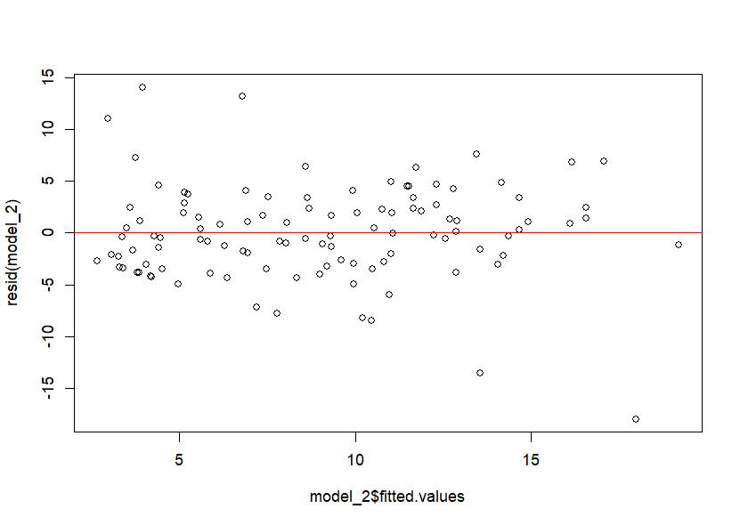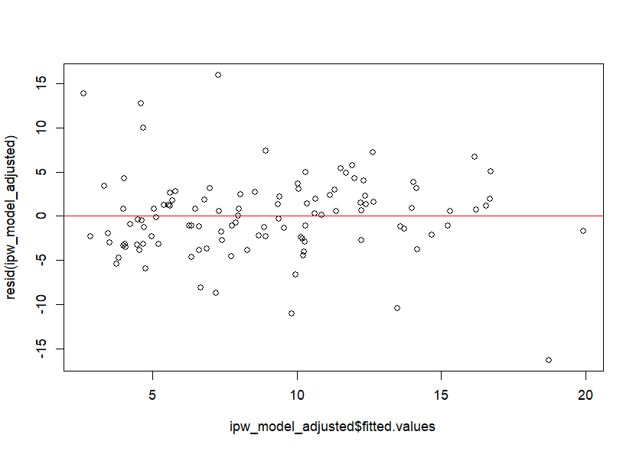

Figure S2. Propensity scores by treatment group.
